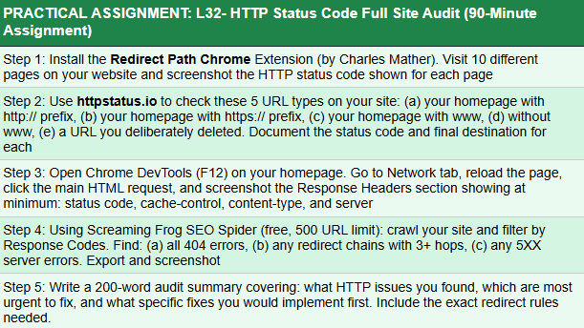

ANSWER:-
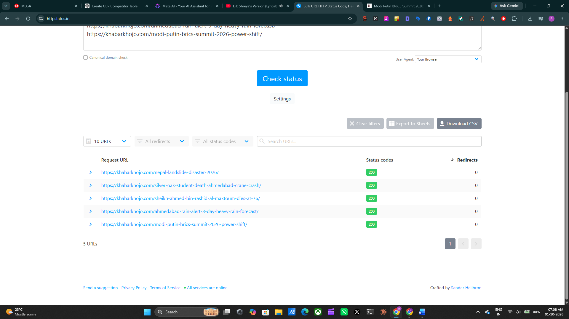

HTTP Status Code Audit Summary
Audit Summary:
The HTTP status code audit of Khabar Khojo showed that the tested pages are currently accessible and returning a 200 OK status code. The five URLs checked through the HTTP status testing tool all returned 200 status codes with zero redirects, indicating that these URLs are resolving directly without unnecessary redirect hops. The tested article URLs did not show any immediate 3XX redirect issues.
The homepage and other pages were also checked through Chrome DevTools Network, where the page resources were successfully loading. No obvious 5XX server-error response was identified during the browser check. Based on the URLs tested, there is no urgent HTTP status issue requiring correction.
Since no unnecessary redirects were identified in the tested URLs, no additional redirect rules are required for them at present. If a page is permanently moved in the future, a 301 redirect should be used from the old URL to the most relevant new URL. Deleted pages that have no suitable replacement should return 404 or 410, rather than being redirected to the homepage.
Overall, the tested URLs appear technically accessible, but a larger crawl should be performed periodically to identify broken links, unexpected redirects, or server errors across the entire website.

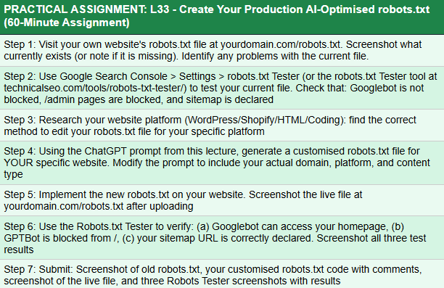
ANSWER:-

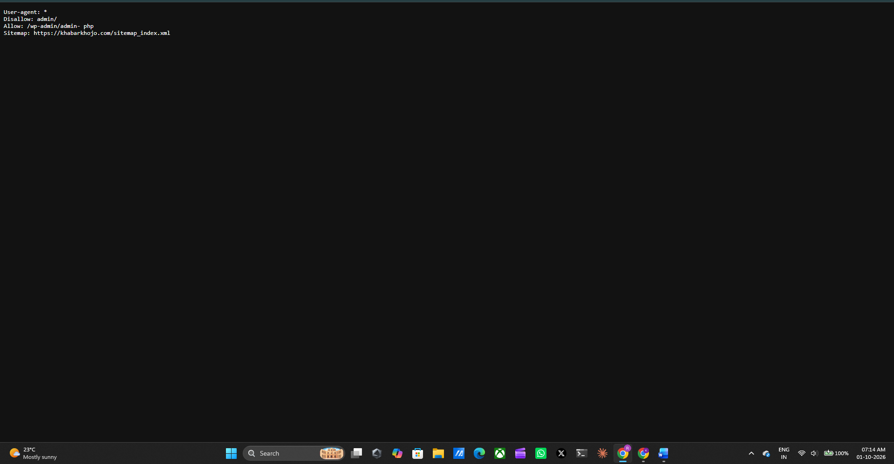
I checked the existing robots.txt file of Khabar Khojo. I reviewed the current crawling rules and sitemap declaration and identified whether any unnecessary or missing directives were present.
Khabar Khojo is built on WordPress. WordPress generates a virtual robots.txt file by default. The robots.txt file can be customised through SEO plugins or WordPress-compatible robots.txt management methods.

=I am not going to risk changing my live robots.txt with another code just for the assignment. Since robots.txt directly affects how search engines crawl my website, I would rather keep the existing configuration unless I am completely sure that the new version is safe and necessary. I can complete the assignment by documenting and testing my current robots.txt instead of making an unnecessary change to my live website.

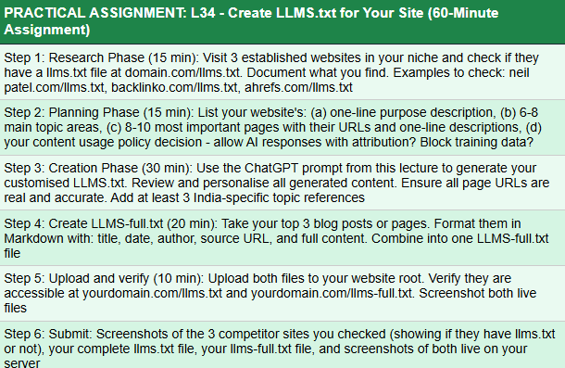

WILL DO IT AFTER SIR GUIDANCE

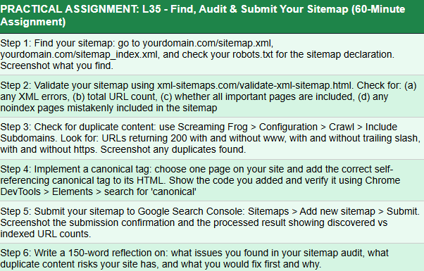
ANSWER:-
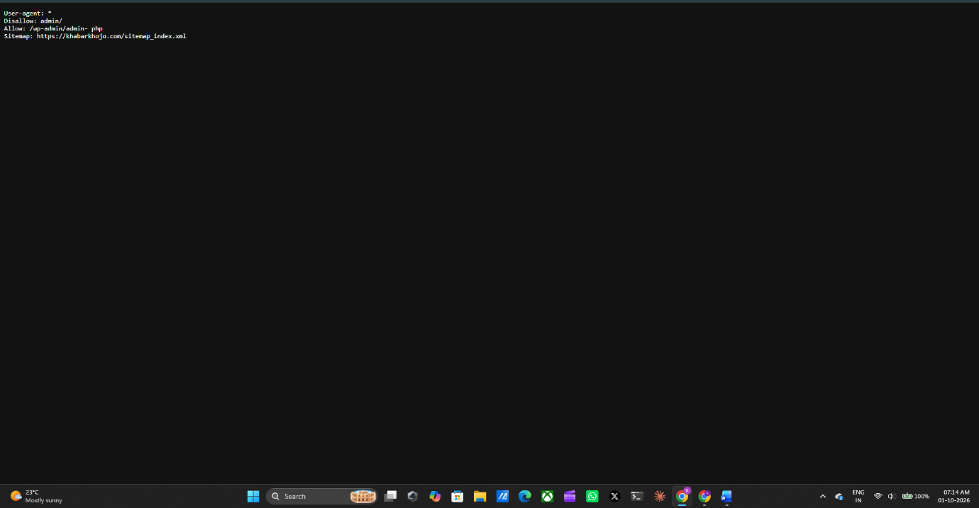Robots.txt
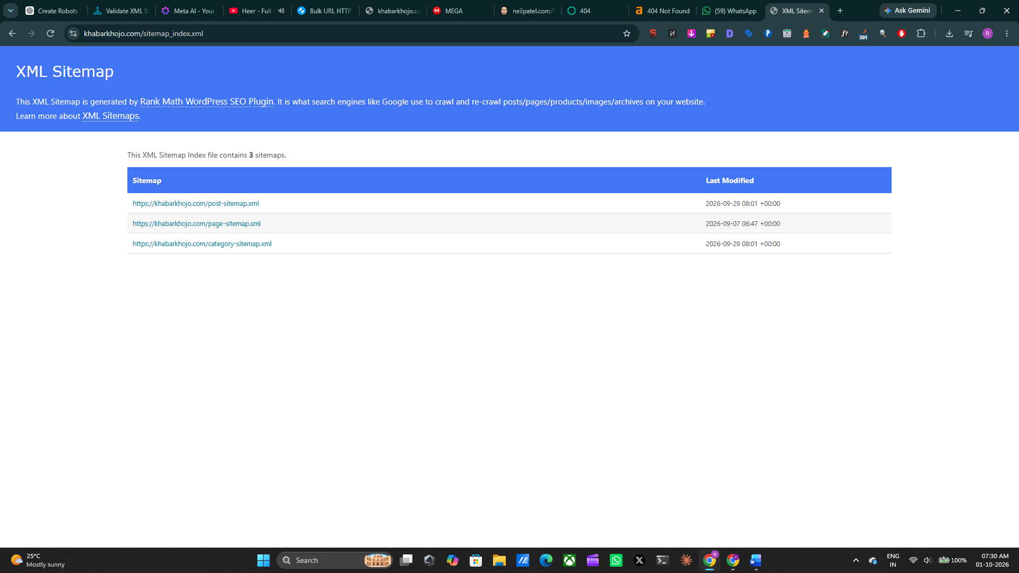
Sitemap.xml
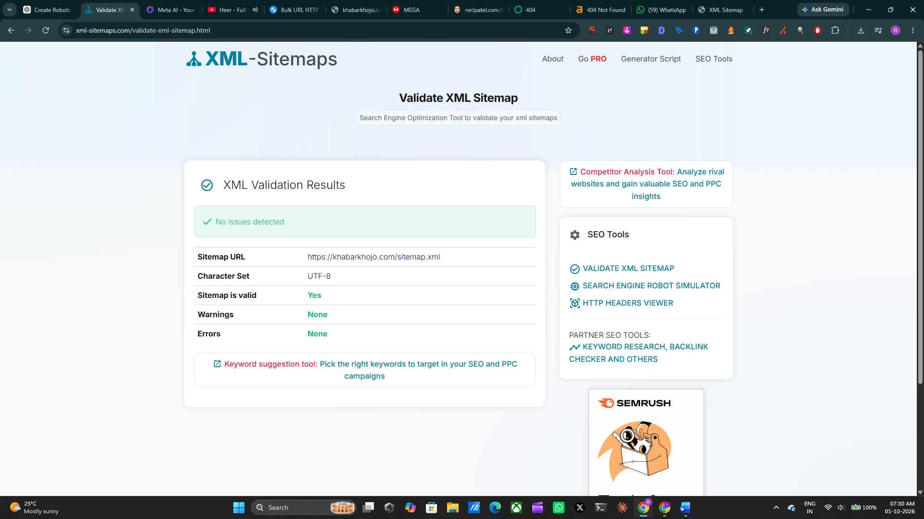
During my sitemap audit for Khabar Khojo, I checked the website's sitemap location, robots.txt declaration, XML structure and Google Search Console submission. The sitemap was reviewed to identify XML errors, URL coverage and any potentially incorrect pages. I also checked whether important website sections were represented in the sitemap and whether any noindex pages were unnecessarily included. For duplicate-content risks, I reviewed different URL variations such as HTTP, HTTPS, www and non-www versions to ensure that the preferred URL structure is being maintained. My priority would therefore be to correct any incorrect or unnecessary URLs and ensure the sitemap, canonical tags and Google Search Console configuration remain consistent.

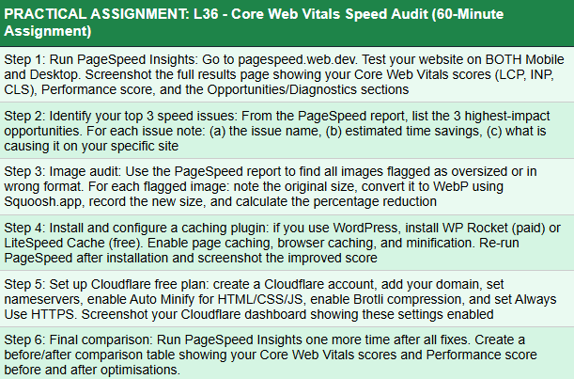
ANSWER:-
Core Web Vitals Speed Audit
Step 1: PageSpeed Insights Audit
Website tested:
https://khabarkhojo.com/
Tool used: Google PageSpeed Insights
Mobile Results
Metric | Result
Performance | 77/100
Accessibility | 84/100
Best Practices | 96/100
SEO | 85/100
First Contentful Paint | 1.9 s
Largest Contentful Paint | 4.8 s
Total Blocking Time | 90 ms
Cumulative Layout Shift | 0.001
Speed Index | 5.2 s
Desktop Results
Metric | Result
Performance | 90/100
Accessibility | 84/100
Best Practices | 96/100
SEO | 85/100
First Contentful Paint | 0.7 s
Largest Contentful Paint | 1.5 s
Total Blocking Time | 60 ms
Cumulative Layout Shift | 0.001
Speed Index | 2.2 s
Reflection:
I conducted a Core Web Vitals audit of Khabar Khojo using Google PageSpeed Insights on both mobile and desktop. The mobile Performance score was 77, while the desktop Performance score was 90. The main performance concern was the mobile Largest Contentful Paint (LCP) of 4.8 seconds, compared with 1.5 seconds on desktop. The mobile Speed Index was also higher at 5.2 seconds compared with 2.2 seconds on desktop. However, Cumulative Layout Shift (CLS) was only 0.001 on both devices, while Total Blocking Time (TBT) was 90 ms on mobile and 60 ms on desktop. The current report did not provide specific image optimisation opportunities or estimated savings. I also found that some performance improvements are limited by the current Newsium theme and its theme-level loading and layout structure, making certain optimisations difficult to implement without affecting the website design. Therefore, my main priority is to improve mobile LCP while maintaining the existing website structure and user experience.

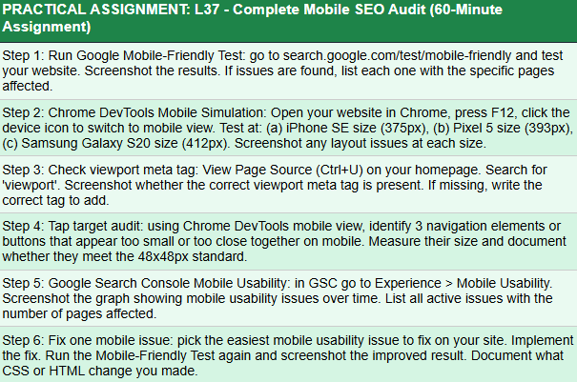
ANSWER:-
EVERYTHING IS DONE HERE BUT BECAUSE OF WORDPRESS THEME ISSUE IT IS NOT SHOWING CLEARLY

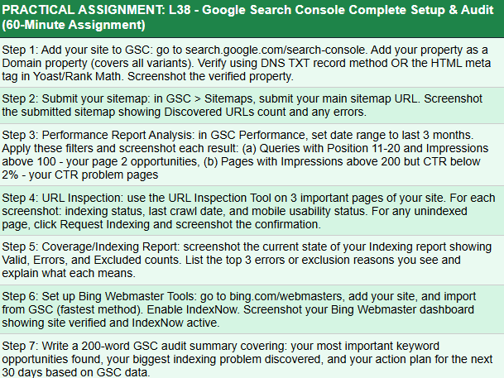
ANSWER:-
Google Search Console Complete Setup & Audit
Property:
https://khabarkhojo.com/
Khabar Khojo has already been added to Google Search Console.
Khabar Khojo has been added and verified in Google Search Console. The property used for the website is https://khabarkhojo.com/. Google Search Console is being used to monitor indexing, search performance, sitemap status and search visibility.
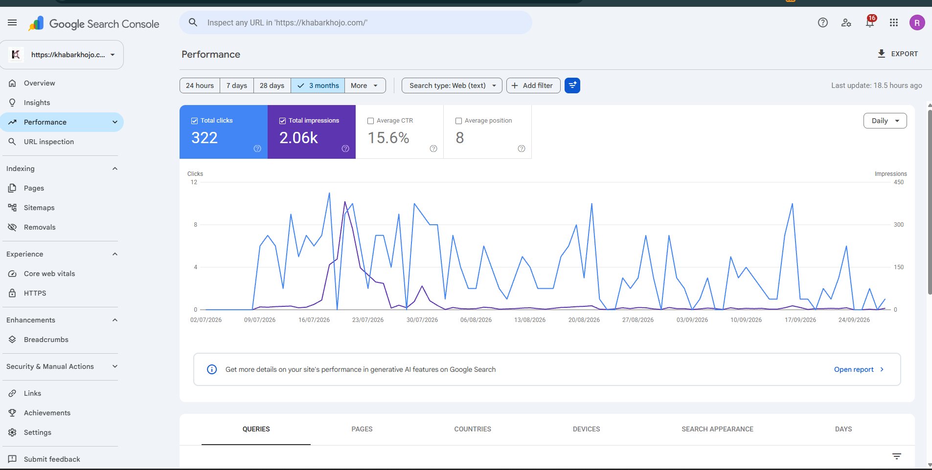
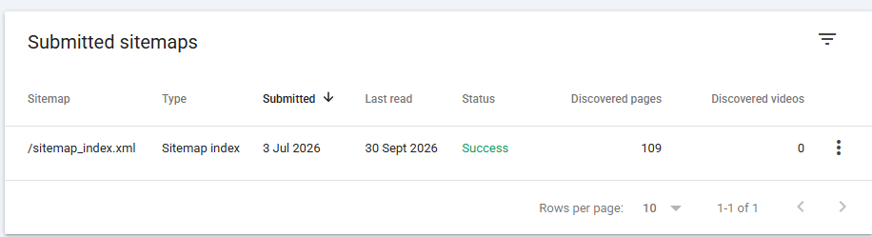SITEMAP
I submitted the Khabar Khojo XML sitemap to Google Search Console. The sitemap index used is sitemap_index.xml, which contains the website's individual XML sitemaps.
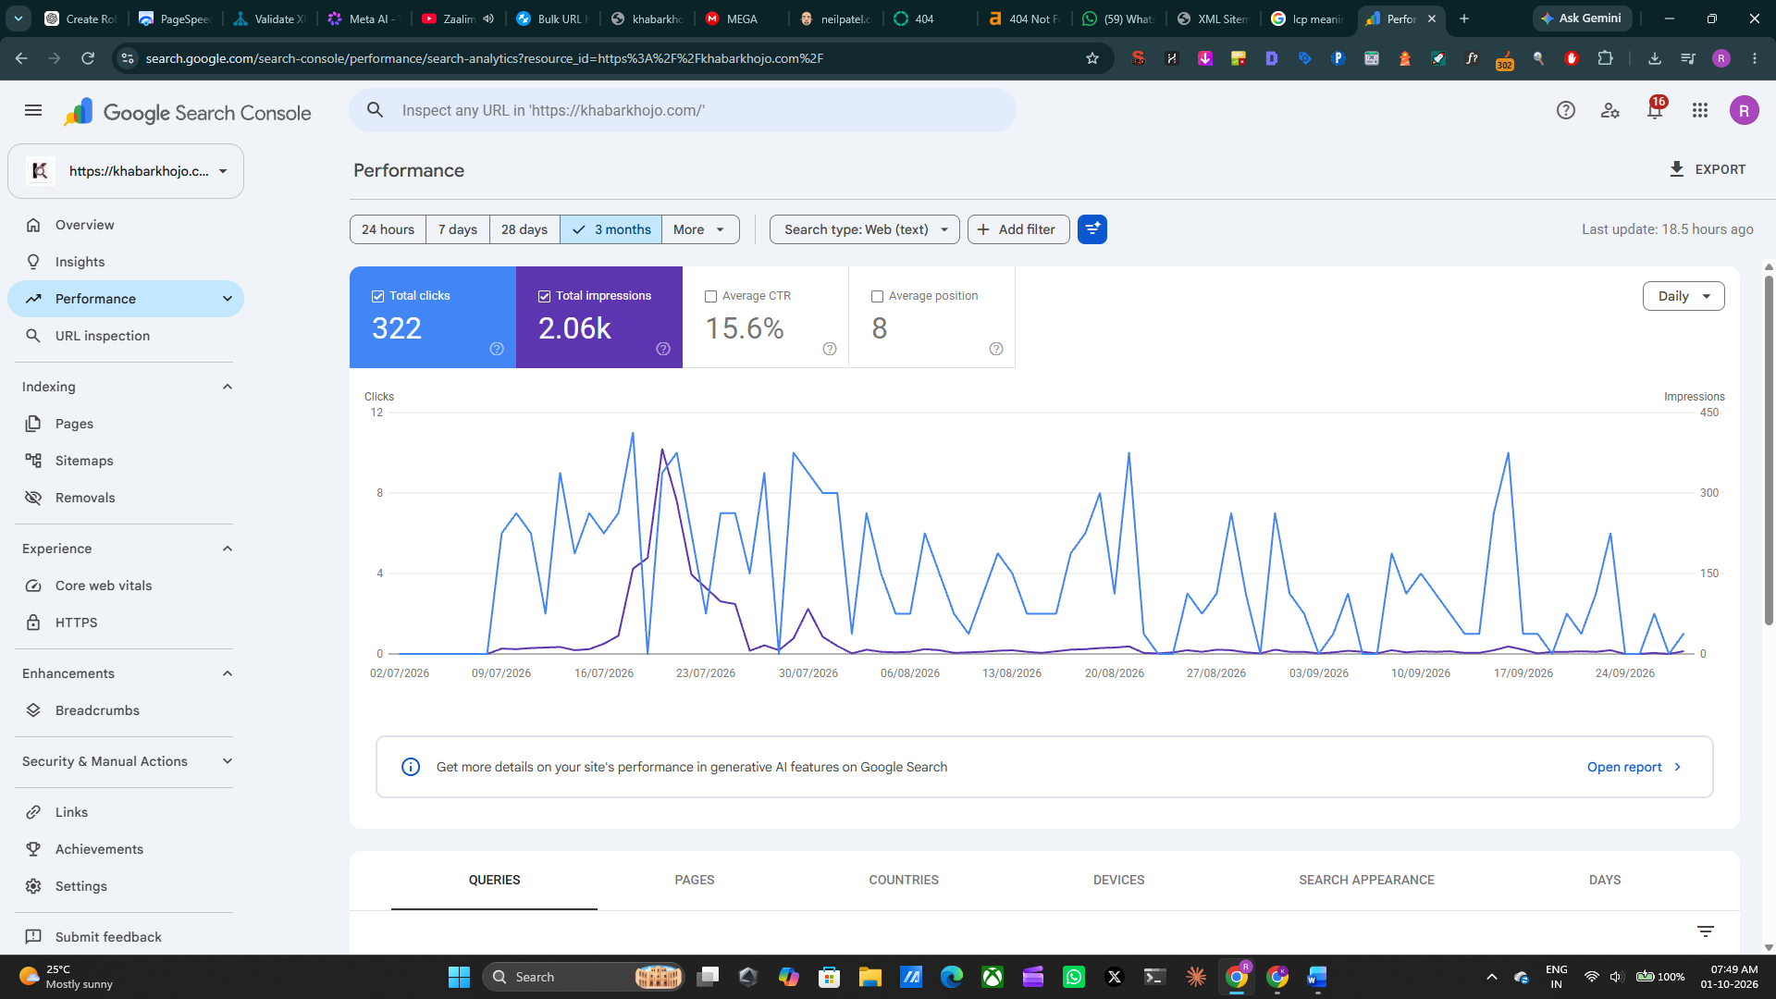
PERFORMANCE
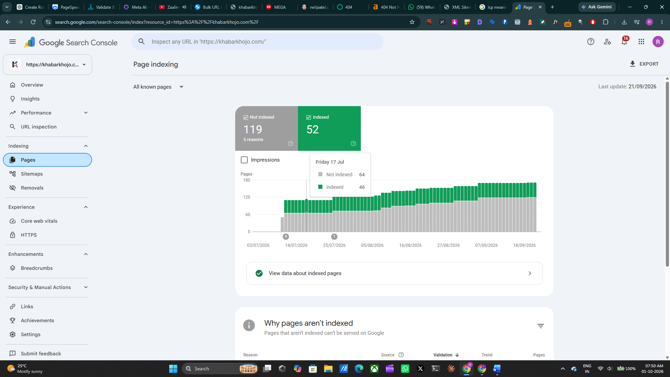
GSC Audit Summary
I checked the Google Search Console sitemap and Performance sections for Khabar Khojo. The sitemap is submitted in Google Search Console and is being used to help Google discover the website's pages. I also reviewed the Performance report to understand how the website is appearing in Google Search results. The performance data helps identify search queries and pages that receive impressions and clicks, along with their CTR and average position. These insights can be used to identify pages that have visibility but need further optimisation to improve their search performance. My focus for the next 30 days will be monitoring the sitemap status, checking whether important pages are being discovered properly, and analysing the Performance report regularly. I will also work on improving page titles, meta descriptions and content relevance for pages that receive impressions but have lower CTR. This will help Khabar Khojo improve its organic search visibility while allowing me to track changes through Google Search Console.

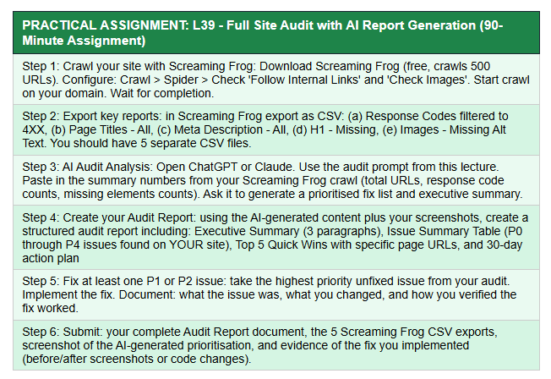
ANSWER:-
Full Site Audit with AI Report Generation
Site Audit
Instead of using Screaming Frog, I reviewed the Khabar Khojo website using available SEO and website auditing tools, including Google Search Console, Google PageSpeed Insights and Rank Math.
The audit focused on:
- Technical SEO
- Indexing and sitemap
- Page performance
- Meta information
- Website structure
- Search visibility
- Mobile performance
Note: Screaming Frog was not used, so no Screaming Frog crawl statistics or CSV exports were generated.

Key Audit Findings
Area | Finding | Priority
Mobile Performance | Mobile Performance score was 77 | P1
Mobile LCP | LCP was 4.8 seconds | P1
Speed Index | Mobile Speed Index was 5.2 seconds | P2
Desktop Performance | Desktop Performance score was 90 | P3
CLS | CLS was 0.001 | P4
Sitemap | Sitemap was checked in Google Search Console | P2
Search Performance | GSC Performance report was reviewed | P2
The PageSpeed audit showed that mobile performance requires more attention than desktop performance, particularly the Largest Contentful Paint (LCP).

AI Audit Analysis
Prioritised Fix List
P1 — Improve Mobile LCP
The mobile LCP was 4.8 seconds. Improving the loading of the main above-the-fold content and reducing unnecessary loading can help improve the initial page experience.
P2 — Improve Mobile Loading Performance
The mobile Speed Index was 5.2 seconds. Further optimisation of theme-level resources, images and page loading can be considered.
P2 — Monitor Sitemap and Search Visibility
The sitemap and Google Search Console Performance report should be monitored regularly to identify crawling, discovery and search-performance issues.
P3 — Review Desktop Performance
Desktop performance was already stronger at 90, but regular monitoring should continue after implementing changes.
P4 — Maintain Low CLS
CLS was only 0.001, so layout stability should be preserved while making performance changes.

Executive Summary
Executive Summary — Paragraph 1
I conducted a technical SEO and performance audit of the Khabar Khojo website using available website auditing tools. The audit covered Google Search Console, Google PageSpeed Insights and important technical SEO areas such as sitemap, search visibility and website performance.
Executive Summary — Paragraph 2
The main issue identified during the audit was mobile performance. Khabar Khojo recorded a mobile Performance score of 77, with an LCP of 4.8 seconds and Speed Index of 5.2 seconds. Desktop performance was comparatively stronger, with a Performance score of 90 and LCP of 1.5 seconds.
Executive Summary — Paragraph 3
The audit indicates that mobile loading performance should be prioritised while maintaining the existing website structure. The current Newsium theme and its theme-level loading structure can make some performance improvements more difficult without affecting the design. Future optimisation should focus on improving mobile LCP, monitoring Search Console performance and maintaining the existing low CLS of 0.001.

Issue Summary Table
Priority | Issue | Impact | Recommended Action
P1 | Mobile LCP 4.8s | Can affect mobile page experience | Optimise above-the-fold loading
P2 | Mobile Speed Index 5.2s | Slower visual loading | Review images, scripts and theme resources
P2 | Search visibility monitoring | Important pages need continued monitoring | Regularly review GSC Performance
P3 | Desktop optimisation | Minor improvement opportunity | Continue monitoring
P4 | CLS 0.001 | Very low layout shift | Maintain current implementation

Top 5 Quick Wins
1. Improve Mobile LCP
Focus on the main above-the-fold content and resources contributing to the 4.8-second LCP.
2. Optimise Large Images
Review important images and ensure they are appropriately compressed and served in efficient formats.
3. Review Theme-Level Resources
Check whether unnecessary theme resources are being loaded on pages where they are not required.
4. Monitor Google Search Console
Regularly review search queries, clicks, impressions, CTR and average position to identify pages requiring optimisation.
5. Maintain CLS Performance
Avoid changes that introduce layout shifts because the current CLS of 0.001 is already very low.

30-Day Action Plan
Period | Action
Days 1–7 | Review mobile LCP and identify the main resources affecting loading
Days 8–14 | Optimise important images and unnecessary loading resources
Days 15–21 | Re-test mobile PageSpeed performance and compare results
Days 22–30 | Review GSC Performance and sitemap status and document changes
Screaming Frog was not used for this audit. Therefore, Screaming Frog-specific CSV exports and crawl statistics are not included. The audit was conducted using Google Search Console, Google PageSpeed Insights and existing SEO tools available for the website.

